**Assignment 2:**

**Produce a comparative infographic of TDD, BDD, and FDD methodologies. Illustrate their unique approaches, benefits, and suitability for different software development contexts. Use visuals to enhance understanding**

Test-Driven Development (TDD), Behavior-Driven Development (BDD), and Feature-Driven Development (FDD) are three distinct methodologies in software development. Each has its unique approaches, benefits, and suitability for different contexts. Here's a detailed comparison:

**1. Test-Driven Development (TDD)**

**Approach:**

* TDD is a software development process where developers write automated test cases before writing the actual code.
* The process follows a repetitive cycle: Write a test → Run the test (it should fail) → Write code to make the test pass → Refactor the code → Repeat.

**Benefits:**

* Ensures that the code meets the specified requirements.
* Reduces bugs and errors in the later stages of development.
* Facilitates better design and more maintainable code.
* Promotes simple, clean, and bug-free code.

**Suitability:**

* Best suited for complex projects requiring high reliability and where the requirements are well understood.
* Useful in environments emphasizing automated testing and continuous integration.
* Ideal for projects where code quality and long-term maintenance are critical.

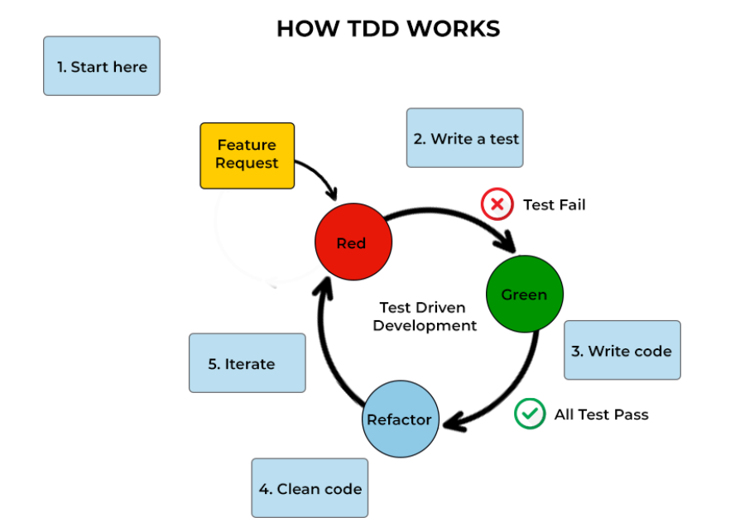

**2. Behavior-Driven Development (BDD)**

**Approach:**

* BDD extends TDD by writing test cases in a natural language that non-technical stakeholders can understand.
* It focuses on the behavior of the application from the end-user’s perspective.
* Test scenarios are written in the Given-When-Then format.

**Benefits:**

* Enhances collaboration between developers, QA, and non-technical stakeholders.
* Provides clear, understandable documentation of the system behavior.
* Ensures that all stakeholders have a shared understanding of the requirements.
* Encourages writing tests that reflect user stories and business language.

**Suitability:**

* Ideal for projects with significant stakeholder involvement and where requirements are likely to evolve.
* Useful in agile development environments where frequent feedback from stakeholders is necessary.
* Suitable for applications with complex business logic and where understanding user behavior is crucial.

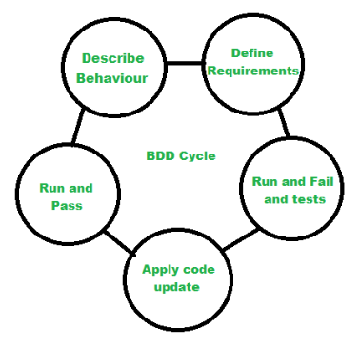

**3. Feature-Driven Development (FDD)**

**Approach:**

* FDD is a model-driven, iterative, and incremental development process.
* It involves developing features, which are small, client-valued functions, within two-week iterations.
* The process includes five main activities: developing an overall model, building a feature list, planning by feature, designing by feature, and building by feature.

**Benefits:**

* Provides a structured, step-by-step approach to development.
* Focuses on delivering tangible, working software frequently.
* Ensures that development aligns with client-valued features.
* Facilitates progress tracking and management of large projects.

**Suitability:**

* Best suited for larger projects with clear, well-defined features.
* Useful in teams requiring a structured approach and where managing complexity is essential.
* Suitable for projects where regular delivery of client-valued features is a priority.

